MEMORANDUM

To: Public Service Commission

From: Division of Public Utilities
Constance White, Director
Energy Section
Artie Powell, Energy Section Manager
Charles Peterson, Technical Consultant
Abdinasir Abdulle, Technical Consultant

Date: November 9, 2006

Ref: Docket No. 05-035-22

ISSUE
On June 2, 2004 and March 22, 2005, PacifiCorp filed major event claims for the events that took place during April 2 through 3, 2004 (Event 11) and January 8 through 11, 2005 (Event 12), respectively. In these filings, PacifiCorp requested designation of these events as major events for exclusion from network performance reporting on the basis that these events exceeded the design or operational limits of the system, resulting in damage to the power system and causing sustained interruptions to more than 10% of customers in the affected operating areas. These events took place before the Commission adopted the 2.5 Beta method of defining major event. Therefore, the Division will use the old definition of major event to evaluate the Company’s claim for exclusion from the network performance reporting.

RECOMMENDATIONS
The Division recommends that the Commission approve PacifiCorp’s request to designate Events 11 and 12 as major events and exclude them from the network performance reporting. After closely reviewing PacifiCorp’s claims, the Division found that Events 11 and 12 exceeded the design and operational limits and caused 10% of the customers in the affected operating areas to experience a sustained outage.
BACKGROUND DISCUSSION
The Company’s reliability predictors are measured in terms of number and duration of disruptions of service. Extreme events outside the Company’s control are excluded from the reliability measures to ensure that extraordinary storms or occurrences do not skew the numbers.
The Division used the IEEE standard to evaluate claims for exclusion pursuant to Scottish Power Merger Condition 31. Each claim for exclusion is accompanied by documentation to support the Company’s assertion that an event exceeded operational or design limits and otherwise met the IEEE major event criteria. The IEEE definition of Major Event as follows:
A major event is an event which exceeds reasonable design or operational limits of the electric power system and during which at least 10% of the customers within an operating area experience a sustained interruption during a 24-hour period.
Ten Percent Criterion
Determining whether at least 10% of the customers within an operating area experienced a sustainable interruption during a 24-hour period is straight forward. The number of customers in a particular operating area whose electric service was interrupted for at least five minutes is determined and divided by the average customer count in that operating area. This will provide the percentage of customers who were interrupted for a sustained period (sustained customers off). If this percentage is 10% or more, then the requirement that at least 10% of the customers within an operating area experience a sustainable interruption during a 24-hour period is fulfilled, otherwise the requirement is not fulfilled.
Operational Limit
On a regular basis, the Company experiences power outages and restores power. In the event of an outage, the operational manager estimates the number of hours that will be required to fully restore power based on the number of outage incidents stacking up, and the number of resources available in the operational area. The Company targets to restore power within three hours for at least 80% of the customers who experienced power outage. However, when a substantial event occurs, that result in numerous outages, the Company tries to restore power within approximately 24 hours. In determining the restoration time, the Company first evaluates the effect of using internal Company resources that are within the operating area experiencing the outage. The internal Company resources are what the Company has available for normal outage restoration in a given operating area. Thereafter the available resource pool is the line staff that can be safely interrupted and moved from other non-restoration activities. The operational manager determines whether the current backlog of outages will take more than 24 hours to fully restore power in an operating area. If it appears that the problem is escalating and that additional resources are required to eliminate the situation, the operational manager and the regional director will discuss, among other things, the scope of the outage (localized and generalized), the required restoration time, and the number of customers affected. If necessary, the Regional Emergency Action Center (REAC) will be activated and outside resources will be called in. The REAC provides a method for securing resources, establishing priorities and managing an outage event that cannot be reasonably resolved using only the available operating district staff. The outside resources consist of Company crews from other operating areas, contract crews, crews from other Companies that entered into Mutual Assistance Agreement (MAA) with PacifiCorp, as well as crews from other Companies and contracts not accessed via an MAA.

Therefore, for one to determine whether or not the operational limits were exceeded, one needs to determine if the Company used resources in excess of the average number of resources needed for normal outage restoration. In any case, once the REAC is activated and outside resources are called in, the operational limits have, by definition, been exceeded.
Design Limit
In general, transmission structures, due to their long slender nature and relatively light point loads, are designed to withstand specific wind-speeds, which is the controlling or limiting condition. Distribution poles, on the other hand, tend to have more point loads along their length. Additionally, their conductor weights, when under ice or other extreme conditions, will create additional stresses, such that these combined loads are those against which the structure must be tested. These parameters are prescribed under the National Electric Safety Code (NESC) by using velocity pressure factors, gust response factors, ice loading conditions and other factors along with wind-speed to establish the proper selection of strength.
It is important that the system be designed with the proper “weak link”. In other words, if failure is imminent (and all designs assume some failure point), failure should be in such a mode that safety is not jeopardized and that property is minimally impacted. As a result, conductors are the weakest link, followed by their attachments (pins, etc.) followed by cross-arms, with poles being the least-favored item to break.
Within the electric delivery system, the transmission system and its components are designed and operated to a higher standard than the distribution system. This would imply that since transmission structures were specified to meet at least 70 mph in Utah, distribution structures would be designed to meet something less than that.
Efforts to Prevent System Damage
The Company adopted a more stringent standard for its eastern system (e.g. Utah), initiated in the early 90s. The new standard equates to strength sufficient to withstand winds of 117 mph for its transmission structures. On the distribution system, the Company instituted a pole test-and-treat program in 2002. It implemented a 16-year inspection cycle for pole strength and an 8-year cycle for pole safety (conductor clearances, etc.). For those poles with insufficient strength, they are prioritized highly and replaced. For those with sufficient strength, they are treated to extend their useful life. Additionally, the Company has modified its transmission and substation lightning design criteria for new and rebuilt facilities. It is currently modifying its distribution lightning design criteria.
EVENT 11
Event Description
On April 2 through 3, 2004, a spring windstorm with light rain and hurricane-force wind (gusts to 83 mph) moved into PacifiCorp’s Metro, Ogden, Layton, and Tremonton causing a wide spread damage on the power system that resulted in a sustained outage (more than 5 minutes) for more than 10% of the customers in those operational areas with 31,762,561 customer minutes lost, 523 sustained incidents, and 120,116 sustained customer interruptions. The total cost of the damage was $800,000 divided between $100,000 for equipment and $700,000 for labor.
Ten Percent Criterion
Event 11 affected customers in the Salt Lake City Metro, Ogden, Layton, and Tremonton operating areas. The average customer counts in these operating areas were 201,107 customers in Salt Lake Metro, 91,128 customers in Ogden, 59,741 customers in Layton, and 8,575 customers in Tremonton. Of these, 21,247 customers (10.6%) in Salt Lake Metro, 73,003 customers (80.1%) in Ogden, 24,862 customers (41.6%) in Layton, and 1,004 customers (11.7%) in Tremonton experienced sustained outage. This shows that in all four of the operating areas at least 10% of the customers experienced a sustained outage.
Operational Limit
During this event, the Company activated its Regional Emergency Action Center in Salt Lake City in order to better manage the event through logistics coordination and communications support. Consequently, the line crews, tree crews and trouble men were augmented substantially by available resources, including staff from other operating areas, contractor employees and technical staff. According to PacifiCorp, within the operating areas identified, approximately 40 full-time equivalents (FTEs) would be required for normal operational limits. However, the company required 408 FTEs. This requirement is more than ten fold the regular operations. Therefore, the Division concludes that the Event exceeded the operational limit.
Design Limit
According to PacifiCorp, this event was initiated by a spring windstorm with peak gusts of 83 mph moving into the area. The storm uprooted trees, blew shingles and siding off homes, and overturned trucks on the highways within the affected area. Tree limbs fell into conductors and wind-whipped lines slapped together, blowing fuses all over Weber and Davis Counties. The storm caused extensive damage to the system. This included 29 broken distribution poles, 8,000 feet of conductor, broken transformers, damaged insulators and other components. It interrupted service to 136 distribution circuits.
According to PacifiCorp, the poles that broke were class 4, 40-foot poles with 220-foot spans, and were originally installed before 1968. Because of their age, PacifiCorp considers them as having 2/3 of their original strength. These poles were loaded with double-circuit power lines. To determine whether the windstorm exceeded the design limit of these poles, one has to determine the maximum wind speed the poles were designed to withstand. Based upon calculations performed by PacifiCorp staff, during this event, in which no allowances were considered for telecommunications or other conductors, the graph shown below was developed. The following graph illustrates the wind speed that the poles were constructed and maintained for to withstand.
The horizontal axis of the graph is the percent of allowable strength adjusted for age (2/3 of the original strength) and the vertical axis of the graph is the wind speed (mph). The three curves labeled as wind speed of strong pole, wind speed of mean strength pole, and wind speed of weak strength pole are the allowable pole strengths for the respective designs to withstand certain level of wind speeds. If the installed pole were 220-foot span class 4 with average strength and 100% of the allowable strength adjusted for age, then the maximum wind speed that the pole can withstand is about 73 mph. Any wind speed over 73 mph would potentially break the pole.
The wind gusts of the storm of June 30, 2004 were 83 mph in Farmington, 79 mph in Ogden, 83 in Layton, and 80 in Centerville. All of these wind gusts exceeded the wind speed the distribution poles were designed to withstand. Therefore, this event exceeded the design limit of the distribution system.

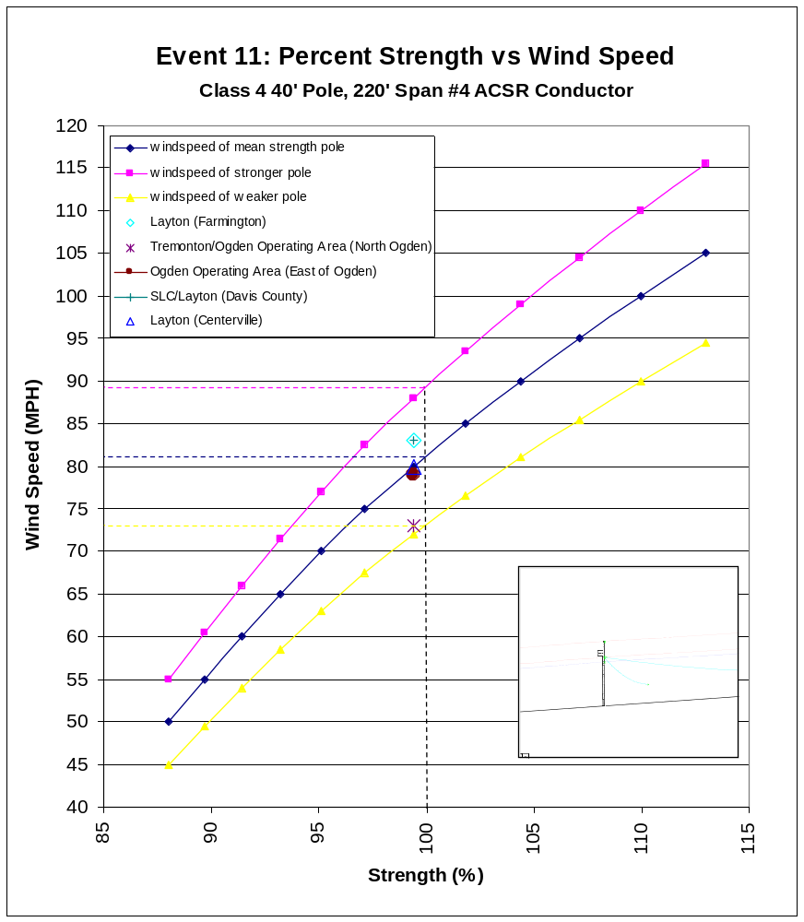

MAJOR EVENT 12
Event Description
On January 8 through 11, 2005, a winter storm with substantial rain and wind gusts recorded at 72 mph passed through several operating areas. The operating areas that experienced sustained outage were Tooele, Price, Smithfield, Cedar City, and Tremonton service areas. The heavy wet snow adhered to conductors and trees weighing the trees down resulting in many significant tree issues, including limb breakage and limbs dipping further toward power lines. Additionally, wind gusts blew through and further stressed the heavily weighed branches. This event caused a widespread damage to the power system and caused more than 10% of the customers in several operating areas (Tooele, Price, Smithfield, Cedar City, and Tremonton) to experience a sustained outage with 5,092,791 customer minutes lost, 274 sustained incidents, and 39,312 sustained customers off. The total cost of the damage was $600,000 divided between $400,000 for labor and $200,000 for equipment.
Ten Percent Criteria
The event of January 8 through 11, 2005 caused a sustained outage to customers in several operating areas, Smithfield, Cedar City, Tremonton, Tooele, and Price. The percentage sustained customers off during this event by operating area is shown in Table 1. Table 1 shows that at least 10% of the customers in all of the five affected operating areas experienced a sustained outage.

Table 1. Percentage Sustained Customers Off During Event Nine
Operating Area | Sustained Customers Off | Average Customer Count | Percentage Sustained Customers Off
Smithfield  Cedar City  Tremonton  Tooele  Price | 9,853  9,036  5,107  10,908  4,408 | 19,064  25,468  8,575  20,288  10,162 | 51.7%  35.5%  59.6%  53.8%  43.4%
Operational Limit
During this event, the Company activated its Regional Emergency Action Center in Salt Lake City in order to better manage the event through logistics coordination and communications support. Consequently, the Company crews were augmented substantially by available resources, including staff from other operating areas including Idaho, contractor employees and technical staff. Therefore, the Division concludes that the Event exceeded the operational limit.
Design Limit
According to PacifiCorp, this event was initiated by a Pacific storm with tropical moisture that moved into Utah. This brought fog, rain, wind (with peak gusts of 72 mph), heavy snow, avalanches, and floods and resulted in extensive damages to the system. This included, in addition to damages insulators and other components, more than 56,000 feet of conductor, 36 broken distribution poles, 10 broken transmission poles, and 88 broken cross-arms. It interrupted service to 72 distribution circuits and 164 substations.
According to PacifiCorp, the poles that broke were class 3, 40-foot poles with 230-foot spans, and were originally installed before 1968. Because of their age, PacifiCorp considers them as having 2/3 of their original strength. To determine whether the windstorm exceeded the design limit of these poles, one has to determine the combination of wind speed, ice loading and tree loads the poles were designed to withstand. Based upon calculations performed by PacifiCorp staff, during this event, in which no allowances were considered for telecommunications or other conductors, the graph shown below was developed. The following graph illustrates the combination of wind speed, ice loading, and tree loading that the poles were constructed and maintained for to withstand.
The horizontal axis of the graph is the radial ice thickness (inches) and the vertical axis of the graph is the wind speed (mph). This graph shows that for a class 3, 40-foot pole with conductors covered by a 1 inch thick ice with trees leaning on it, the maximum tolerable wind speed is less than 40 mph. This indicates that 72 mph wind speed and about 2 inch thick ice exceeded the design limit of the poles. Therefore, the Division concludes that this event exceeded the design limit of the distribution system.

CC: Rea Petersen, DPU
Doug Bennion, Rocky Mountain Power
Dan Gimble, CCS

