September 18, 2015

AL 2015-P11
(UT2015-011)

Public Service Commission of Utah
160 East 300 South, 4th Floor
Salt Lake City, Utah 84111

Dear Commissioners:

Attached for your notification are changes to the Qwest Corporation d/b/a CenturyLink QC Exchange and Network Services Price List. The following pages are attached:

Exchange and Network Services Price List
Section | Page | Release
5 | 25 | 8
5 | 26 | 8
105 | 13 | 8
105 | 22 | 6
105 | 46 | 2
105 | 51 | 5
105 | 80 | 3
105 | 83 | 3
9 | 108 | 3

This filing increases the monthly rates for business lines and various business packages.

If you have any questions regarding this filing, you may contact me at (318) 340-5328.

Sincerely,
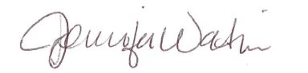

Jennifer Watkins
JENNIFER WATKINS
Tariff Analyst II
Jennifer.Watkins@Centurylink.com
100 Centurylink Drive
Monroe, LA 71203
voice: (318) 340-5328

cc: David Ziegler, CenturyLink
James Farr, CenturyLink
Eric Isom, CenturyLink
Bob Brigham, CenturyLink

UT 2015-011 (QC)

