Andrew O. Isar | 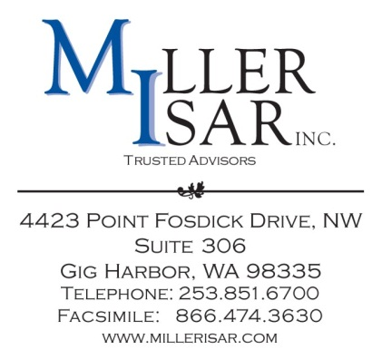
Via Electronic Delivery and U.S. Mail

May 15, 2015

Mr. Gary Widerburg
Commission Secretary
Utah Public Service Commission
Heber M. Wells Building, 4th Floor
160 E. 300 South
Salt Lake City, Utah 84111

Re: Granite Telecommunications, LLC Tariff Advice Letter No. 7

Dear Mr. Widerburg:

Granite Telecommunications, LLC (“Granite”) submits to the Utah Public Service Commission this notice of compliance with the Federal Communications Commission’s (“FCC”) Report and Order and Further Notice of Proposed Rulemaking, in Docket Nos. WC Docket No. 10-90, et al., FCC 11-161, Second Order on Reconsideration in Docket Nos. WC Docket No. 10-90, et al., FCC 12-47, and Section 51.911(c) of the FCC’s rules, 47 C.F.R. §51.911(c).

Granite will comply with the above cited orders and rule by continuing to set its intrastate terminating rates at or below parity with the corresponding incumbent local exchange carriers rates in its operating territory that become effective July 1, 2015. Granite’s Utah switched access price list, Utah Price List No. 2, already adopts the corresponding compliant terminating access rates by citation to the Company’s Tariff F.C.C. No. 1, obviating the need for further intrastate tariff amendments to comply with the July 1, 2015 terminating access rate reductions. The Company’s F.C.C. Tariff No. 1 may be viewed at https://apps.fcc.gov/etfs/public/tariff.action?idTariff=442.

Mr. Gary Widerburg
May 28, 2015
Page 2

Thank you for your attention to this matter. Questions concerning this filing may be directed to the undersigned.

Sincerely,

MILLER ISAR, INC.

/s/ Andrew O. Isar

Andrew O. Isar

Regulatory Consultants to
Granite Telecommunications, LLC

Connect America Fund et al., WC Dkt. No. 10-90 et al., Report and Order and Further Notice of Proposed Rulemaking, FCC 11-161 (rel. Nov. 18, 2011) (USF/ICC Transformation Order).
Id., Report and Order and Further Notice of Proposed Rulemaking, FCC 12-47 (rel. April 25, 2014)

