Andrew O. Isar | 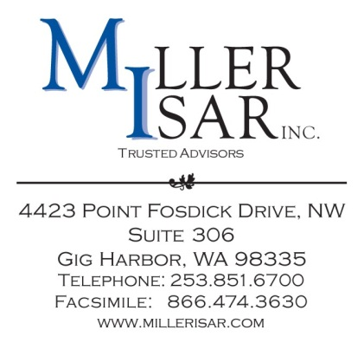
Via Electronic Delivery and U.S. Mail

May 15, 2015

Mr. Gary Widerburg
Commission Secretary
Utah Public Service Commission
Heber M. Wells Building, 4th Floor
160 E. 300 South
Salt Lake City, Utah 84111

RE: TNCI Operating Company LLC, Tariff Advice Letter No. 4

Dear Mr. Widerburg:

TNCI Operating Company LLC (“TNCI OpCo”) submits to the Utah Public Service Commission (“Commission”) this notice of compliance with the Federal Communications Commission’s (“FCC”) Report and Order and Further Notice of Proposed Rulemaking, in Docket Nos. WC Docket No. 10-90, et al., FCC 11-161, Second Order on Reconsideration in Docket Nos. WC Docket No. 10-90, et al., FCC 12-47, and Section 51.911(c) of the FCC’s rules, 47 C.F.R. §51.911(c).

TNCI OpCo will comply with the above cited orders and rule by continuing to set its intrastate terminating rates at parity with the corresponding incumbent local exchange carriers rates in its operating territory that become effective July 1, 2015. TNCI OpCo’s Utah switched access Price List, Utah Price List No. 2, already adopts the corresponding incumbent terminating access rates by citation to the Company’s Tariff F.C.C. No. 1, obviating the need for further tariff amendments to comply with the July 1, 2015 terminating access rate reductions. The Company’s F.C.C. Tariff No. 1 may be viewed at https://apps.fcc.gov/etfs/public/lecTariffs.action?idLec=611.

Mr. Gary Widerburg
May 15, 2015
Page 2

Please acknowledge receipt of this filing by file stamping and returning the additional copy of this transmittal letter in the self-addressed, stamped envelope provided for this purpose.

Thank you for your attention to this matter. Questions may be directed to the undersigned.

Sincerely,

MILLER ISAR, INC.

/s/ Andrew O. Isar

Andrew O. Isar

Regulatory Consultants to
TNCI Operating Company LLC

Connect America Fund et al., WC Dkt. No. 10-90 et al., Report and Order and Further Notice of Proposed Rulemaking, FCC 11-161 (rel. Nov. 18, 2011) (USF/ICC Transformation Order).
Id., Report and Order and Further Notice of Proposed Rulemaking, FCC 12-47 (rel. April 25, 2014)

